Building the Bidirectional Heuristic Search Playground
Nov 8, 2026 · @NOWFALN

Starting point
build an interactive playground for Bidirectional Heuristic Search, and document the build from start to finish. There was no code, no framework and no design to inherit. I built the site in a single session.
A good playground lets you change a setting and see the effect straight away. For search, that meant choosing a map, turning heuristics on or off, pressing play and watching the two frontiers meet. My main task was deciding which parts of a search should be controls and which should be displays.

Background: why bidirectional heuristic search is hard
Bidirectional heuristic search runs one search forward from the start and one backward from the goal, each guided by an estimate of the distance left. The appeal is simple: two searches of half the depth can touch far fewer nodes than one full-depth search.
The difficulty is knowing when to stop. The first path the two frontiers form may not be the shortest, so a correct algorithm keeps searching until it can prove nothing cheaper exists. That proof uses two numbers:
- U, the upper bound: the cost of the best complete path found so far.
- LB, the lower bound: a value no undiscovered path can beat.
The search may stop once U is less than or equal to LB. The algorithms in this project differ mainly in which node they expand next and how they compute LB. A second problem is that heuristics help less than you would expect here: Barker and Korf (2015) showed that a strong heuristic can make bidirectional search expand more nodes than A*. A useful playground has to make that visible, so A* stays in the comparison as a baseline.

Design decisions
Each part of the page stands for one idea in search, so a change to a control shows up straight away on the grid and the charts.
Part of the site | What it does in the search
Six map presets | Set how hard the problem is
Random walls slider | Adds disorder to the same base shape
Five heuristic tiles with field previews | Choose the information the search is given
Forward and backward frontier tiles | Show each side's current state on its own
Heuristic weight w | Trades path quality for speed with one number
Algorithm menu | Changes the rule applied at each step
Expansion counter | Counts units of work
Proof closing chart (U and LB) | Shows the distance left to a finished answer
Grid with Frontiers, Territory and Heuristic views | Shows what the search has done so far
Three technical choices shaped the rest:
- Plain HTML, CSS and JavaScript. There is no framework or build step, and engine.js has no page code, so the browser and the tests run the same file.
- Simple open lists. Open nodes sit in an ordinary array that is scanned at each step. Grids stop at 81 by 49, so this is fast enough, and rules such as NBS pair selection stay readable.
- Replay for scrubbing. Moving back in time re-runs the search to that step, which removes the need to store snapshots. The slowest full run measured on the largest grid took 14 ms.

Building the search engine
The engine was written first, because a wrong algorithm in a good interface would teach the wrong thing. All eight algorithms share one loop and differ only in the rules that plug into it.
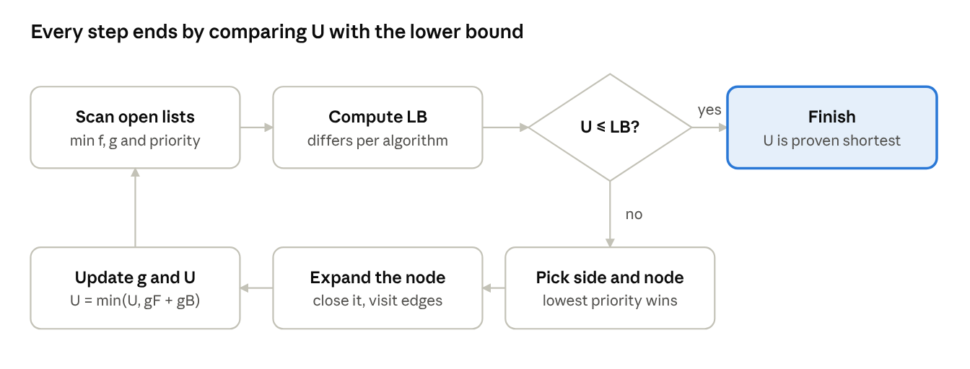
one step of the search loop, shared by all eight algorithms
NBS is the one variation: it picks one node from each side as a pair and expands both. If an open list empties, the loop also stops, since no undiscovered path can remain.
Algorithm | Priority (lowest first) | Default side | Stops when U ≤
MM | max(f, 2g) | Lowest priority | max(C, fminF, fminB, gminF + gminB + ε)
NBS | Pair lower bound | Both, as a pair | Best pair's lower bound
BS* | f | Smaller frontier | max(fminF, fminB)
BHPA | f | Smaller frontier | max(fminF, fminB)
Balanced Bi-A* | g ± (hF − hB) / 2 | Smaller frontier | kminF + kminB
Front-to-Front | g + nearest opposite-frontier estimate | Smaller frontier | max(fminF, fminB)
Bidirectional Dijkstra | g | Lowest priority | gminF + gminB + ε
A* (baseline) | f | Forward only | fmin
Here g is the cost so far, h the estimate of the remaining cost and f = g + h. C is the smaller of the two minimum priorities, k is a Balanced Bi-A* key, and ε = 1 is the cheapest edge on the grid.
Front-to-Front needed one extra idea. Its estimate depends on the other frontier, so recalculating every node at every step would be slow. A saved estimate stays a valid lower bound as the other frontier advances, so the engine only refreshes the node it is about to pick.

Testing the algorithms
All eight algorithms returned the exact shortest cost in 24,192 of 24,192 test runs. Each answer was compared with a separate Dijkstra search, so an error in the bidirectional code could not hide itself. test-engine.js covers:
- nine map types, twelve seeds each, including walls and mud
- seven movement and heuristic combinations, with 4 and 8 directions
- all eight algorithms with all four side-selection rules
- 160 disconnected maps, all of which correctly reported no path
The same runs checked three further properties, with no failures: every returned path really costs what the algorithm reported, MM never expanded a node past half the optimal cost, and min(U, LB) never exceeded the true cost at any step.
A test that has never failed proves little, so stopping rules were then broken on purpose. Each row below ran on 210 maps.
Deliberate fault | Wrong final cost | Bound check failed
BHPA stops at first meeting | 210 | 210
MM lower bound +2 | 2 | 75
MM lower bound +6 | 5 | 184
Balanced lower bound +2 | 2 | 132
Balanced lower bound +6 | 4 | 205
Bi-Dijkstra ε of 3 | 1 | 174
Front-to-Front lower bound +4 | 10 | 202
A* lower bound +4 | 0 | 194
The table explains why the step-by-step bound check was added. Comparing final costs alone misses most small faults, because the best path has often been found already when a faulty rule stops early.

Building the interface
The interface was built in one pass on top of the tested engine, as a single index.html that loads engine.js.
- Map panel. Six presets with thumbnails, plus sliders for width, random walls and mud. Mud cells cost 5, so the maps have more than uniform step costs.
- Heuristic panel. Five tiles show each estimate as a field across the map. Selecting several takes their maximum, which stays admissible. Curved links run to the two frontier tiles, and link thickness follows the weight w.
- Grid. A canvas draws the frontiers, the current best path and the meeting node. You can paint walls or mud and drag the start and goal, and the search re-runs at once.
- Output panel. Live values for U, LB and the gap, the Proof closing chart, a frontier size chart, and bars comparing all eight algorithms on the current map.
- Explanation below the board. A short reading guide, six one-click experiments and a reference table of the algorithms.
Orange and blue mark forward and backward everywhere on the page. Both colour pairs passed a colour-blindness check in the light and dark themes, and the buttons, menus and sliders work from the keyboard. Drawing on the grid needs a mouse or touch.

Problems found and how they were fixed
Seven problems came up during the build, listed in the order they appeared. None were algorithm bugs. The engine passed its first full run, so the time went into checking the tests and the claims on the page.
Problem | How it was found | Fix
Final-cost tests missed small stopping-rule errors | Deliberately broken rules still passed 60 of 60 runs | Added the min(U, LB) check at every step
Dark theme colours were too bright | Palette check: lightness 0.751 and 0.723 against a 0.67 limit | Changed to darker orange and blue, then re-ran the check
Symbols such as ≤ and × appeared garbled | First browser screenshot | Declared UTF-8 in the page
Phone layout rendered at desktop width | Phone-size browser test | Added the viewport setting
Proof chart was squashed against the bottom | Desktop screenshot | Skipped the placeholder bound recorded before the first step
Page claimed most work happens after the first meeting | Measurement: only 1% to 42% of steps came after it, depending on the algorithm | Rewrote the sentence on the site and in this document
Table said Front-to-Front always had the fewest expansions | Comparison numbers: A* was lower on three map types, and Balanced Bi-A* was lower on Swamp | Changed the wording to "often needs few expansions"

The finished site
The finished site is the Bidirectional Search Playground, a private page that other people can open once it is shared with them. It loads part-way through a run on the Traps map, with no setup.
- Choose a map on the left, or draw on the grid.
- Turn heuristic features on or off and set the weight w.
- Pick an algorithm and press play, or step with the arrow keys.
- Watch U and LB close on the Proof closing chart.
- Compare all eight algorithms in the bars at the bottom right, and click one to switch.
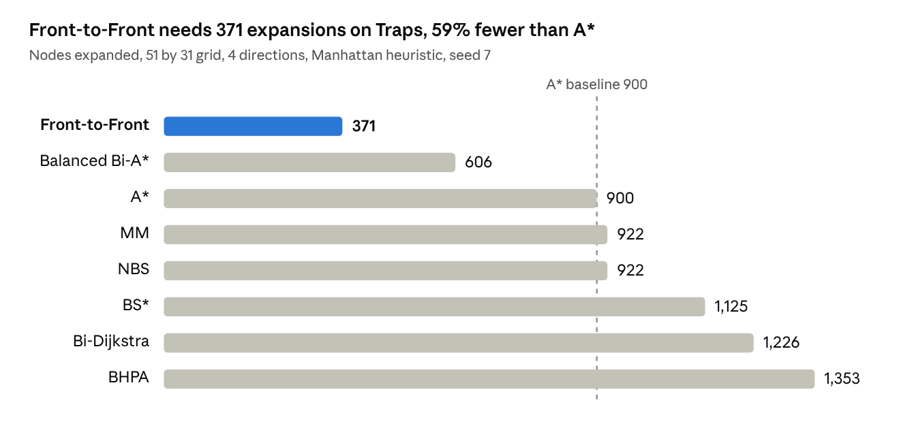
measured with engine.js on the site's Traps map
The result depends heavily on the map, which is what the playground is for:
- A* can win. On Rooms, A* took 293 expansions and Front-to-Front 304. BHPA took 380 and MM 523.
- Landmarks help in mazes. On Maze, BS* fell from 502 expansions with Manhattan to 220 with landmark distances.
- Weight trades away quality. On Scatter, BHPA with w = 1.6 returned a path of cost 66 when the shortest was 62.
- The wrong estimate breaks the guarantee. With diagonal moves and Manhattan only, the same map gave 58.1 when the shortest was 56.7.
- The first connection is often already right. Over 200 maps it was the shortest path 96% of the time with MM, but 72% with BHPA.
The project is three files: index.html for the page, engine.js for the algorithms and test-engine.js for the checks.

Limitations and possible next steps
The playground covers grid maps only, so it shows nothing about search on road networks or puzzle state spaces.
- Grids stop at 81 by 49 because the open lists are scanned at every step. Larger maps would need priority queues.
- A map cannot be saved or shared as a link, and hand-drawn walls are lost when a map slider moves.
- Testing covered Node and one Chromium-based browser pane, at phone, tablet and desktop widths. Safari and Firefox were not tried.
- A useful next step would be a must-expand view showing which node pairs any admissible algorithm has to examine.

References
These citations were written from memory and were not checked against the papers during the build, so verify them before formal citation.
- Pohl, I. (1971). Bi-directional search. Machine Intelligence 6.
- Nicholson, T. A. J. (1966). Finding the shortest route between two points in a network. The Computer Journal.
- Hart, P., Nilsson, N., and Raphael, B. (1968). A formal basis for the heuristic determination of minimum cost paths. IEEE Transactions on Systems Science and Cybernetics.
- de Champeaux, D. (1983). Bidirectional heuristic search again. Journal of the ACM.
- Kwa, J. (1989). BS*: An admissible bidirectional staged heuristic search algorithm. Artificial Intelligence.
- Ikeda, T., et al. (1994). A fast algorithm for finding better routes by AI search techniques. IEEE Vehicle Navigation and Information Systems Conference.
- Barker, J., and Korf, R. (2015). Limitations of front-to-end bidirectional heuristic search. AAAI.
- Holte, R., Felner, A., Sharon, G., and Sturtevant, N. (2016). Bidirectional search that is guaranteed to meet in the middle. AAAI.
- Chen, J., Holte, R., Zilles, S., and Sturtevant, N. (2017). Front-to-end bidirectional heuristic search with near-optimal node expansions. IJCAI.

